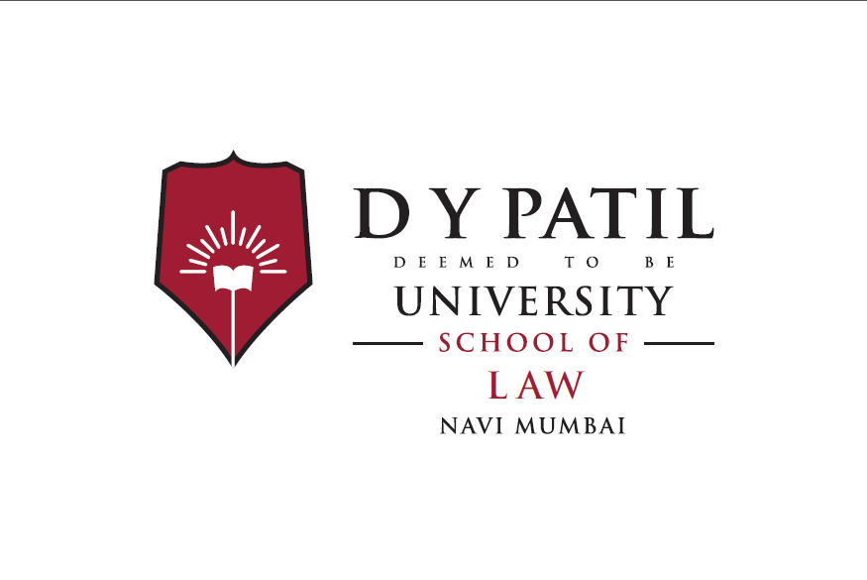

**NOTICE DATE-20/3/2020**

This is to inform all students of B.A LL.B, B.Com LL.B, & LL.B that due to the impending threat of the pandemic COVID-19, Dy Patil University School of Law has decided to postpone **Internal Semester Examination of Semester II** which is scheduled from 31.03.2020 till further orders. Internal Examination shall be rescheduled soon.