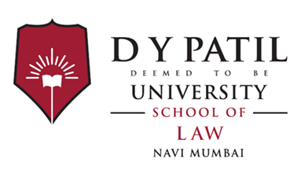

**DATE: 15/9/2020**

**NOTICE**

This is to inform all students of LLB, BCOMLLB and BALLB that kindly furnish/submit all required documents for enrolment procedure of DY Patil Deemed to be University. Kindly keep note that University needs to enrol you with all respective documents asked time to time. If documents not submitted on time by any student then in that case his or her LMS will be blocked until they submit or contact respective faculty of School of law.

**For any query contact faculty:**

1) Prof Ashish Anand

2) Adv Abhilasha Mane

Thank you,

**Adv Abhilasha Mane**

**SCHOOL OF LAW**

**DY PATIL DEEMED TO BE UNIVERSITY**